NAME: HARSHINI P R SLOT - D
REG NO: 192525165 COURSE:CSA1407

COMPILER DESIGN

CASE STUDY

SET 1
Q1. Parse Tree / Syntax Tree Representation

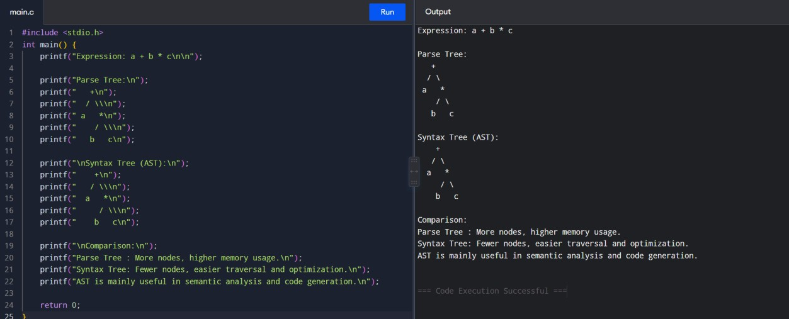
Q2. Bottom-Up Evaluation
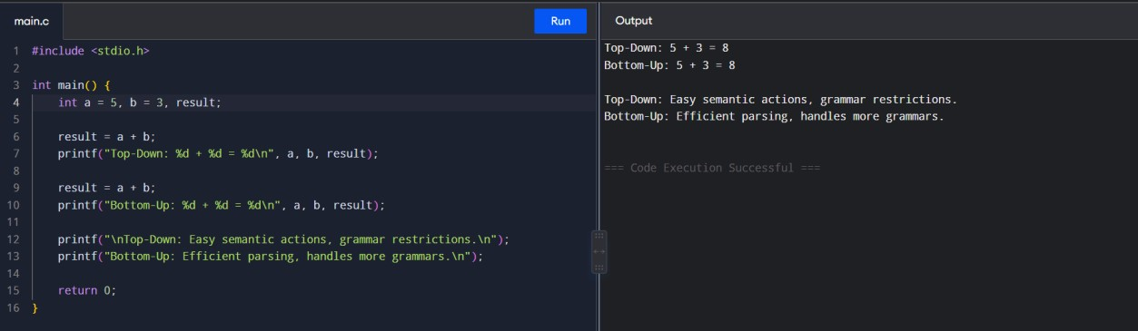

Q3. Attribute Dependency
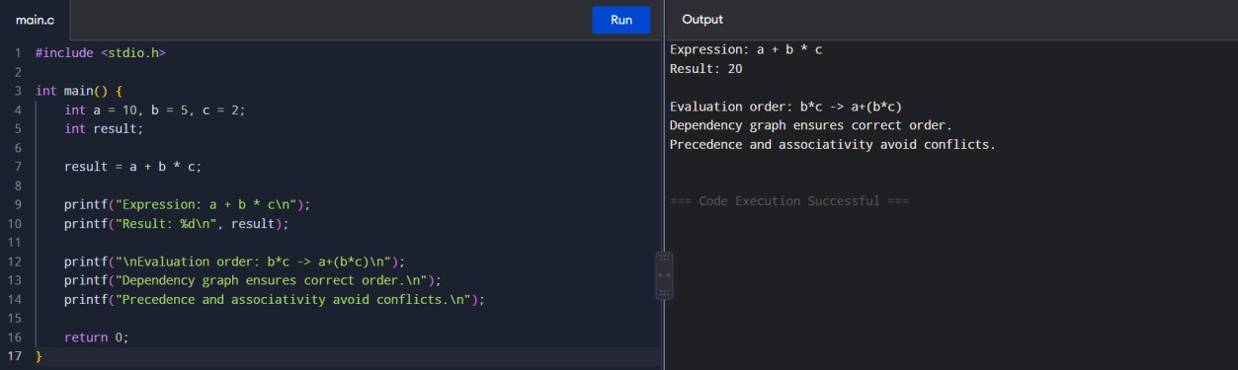
Q4. Static Type Checking
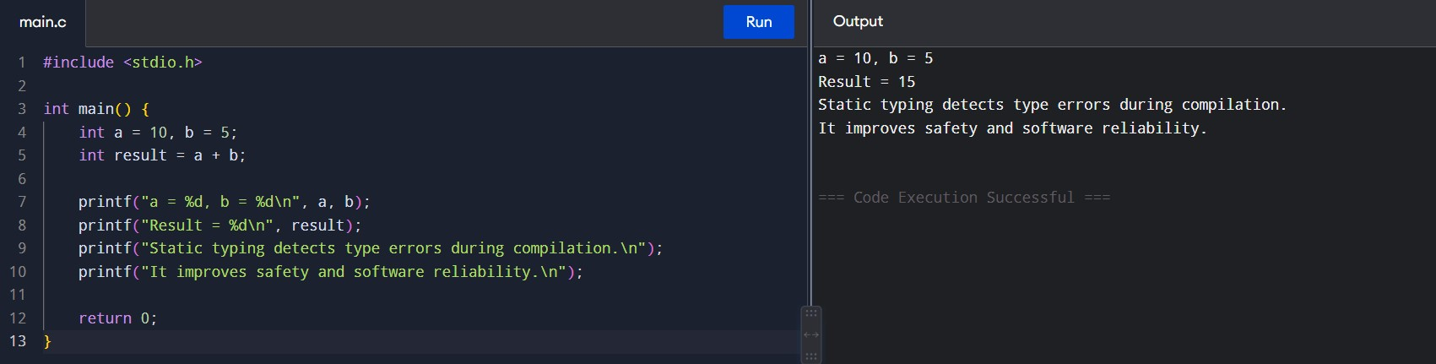

Q5. Function Overloading / Type Resolution Demonstration
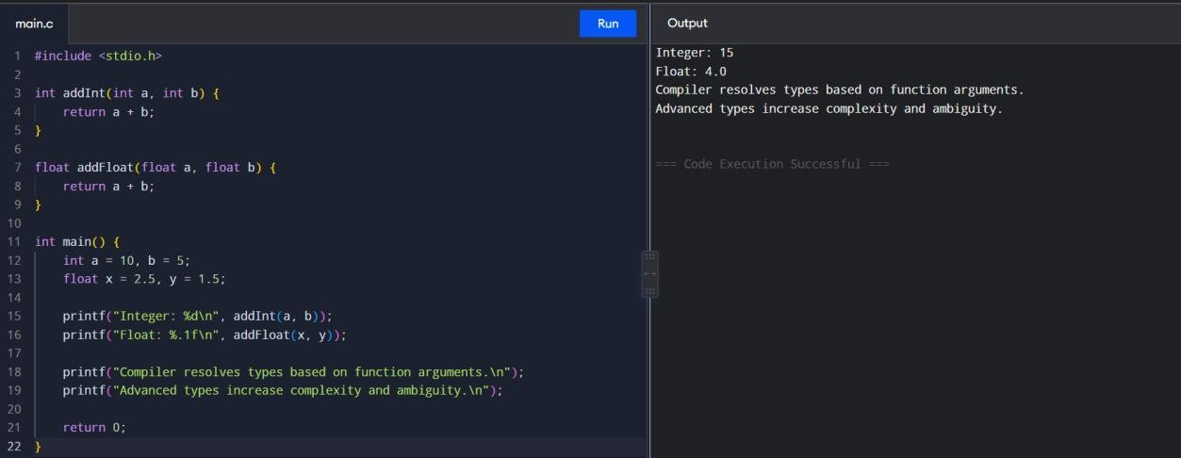

SET 2
Q1. Synthesized Attribute
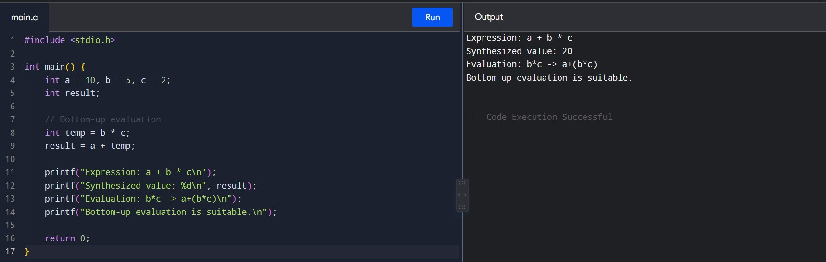
Q2. Type Conversion
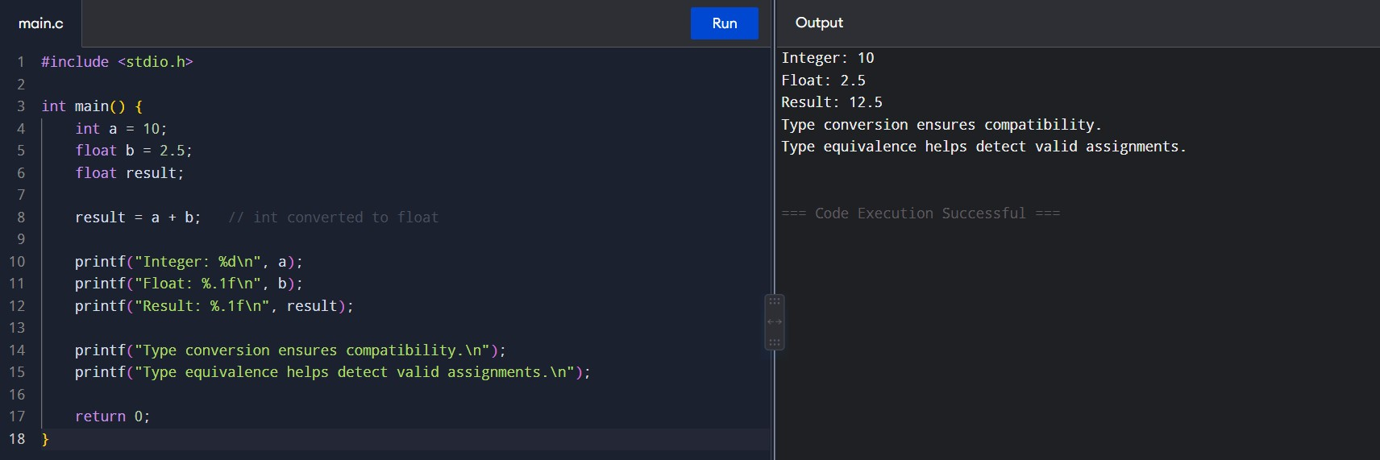

Q3. Syntax Tree and Bottom-Up Evaluation
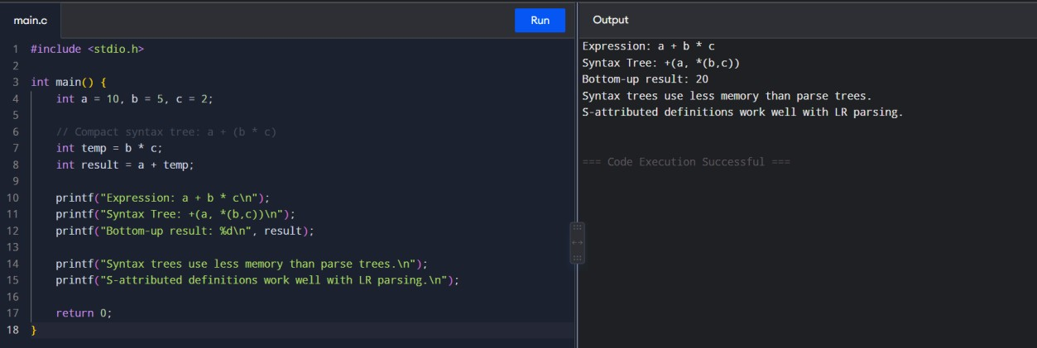

Q4. Left-to-Right Attribute Evaluation
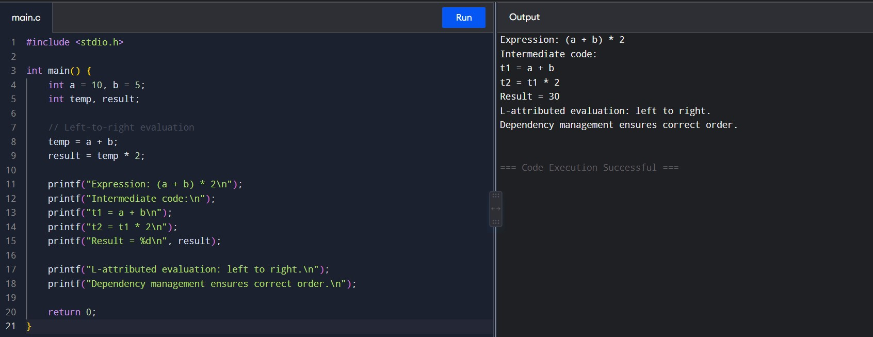
Q5. Type Checking
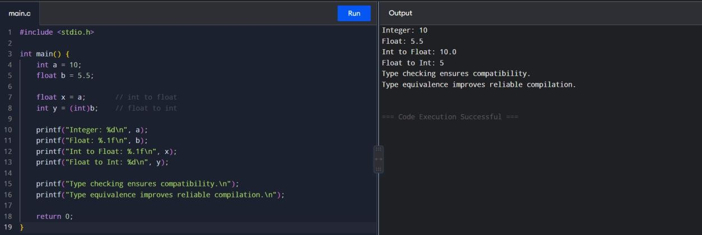
SET 3
Q1. Syntax-Directed Definition – Expression Evaluation
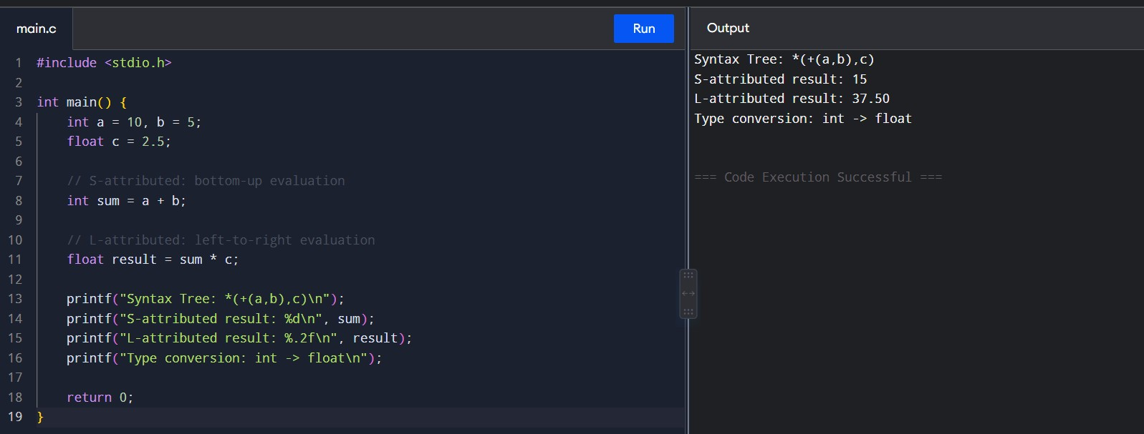
Q2. Type Checker with Type Conversion
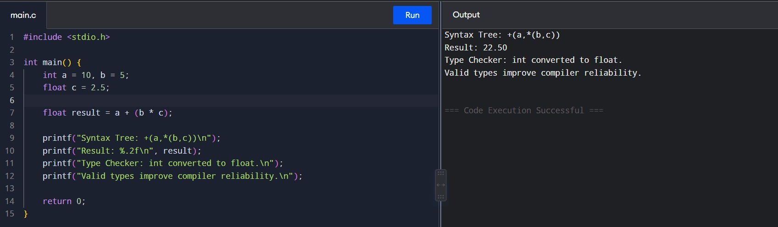

Q3. Bottom-Up Expression Evaluation
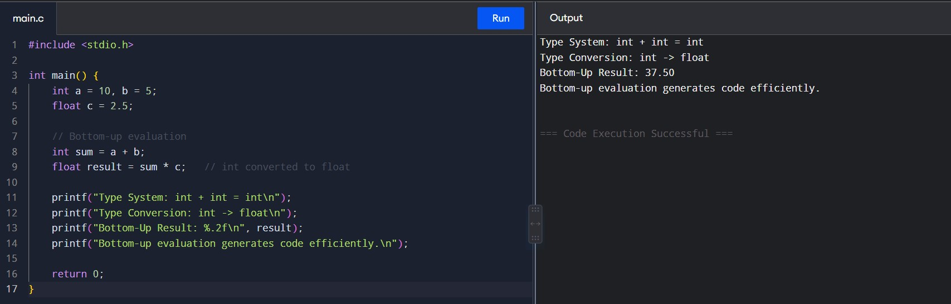
Q4. Type Equivalence Checking
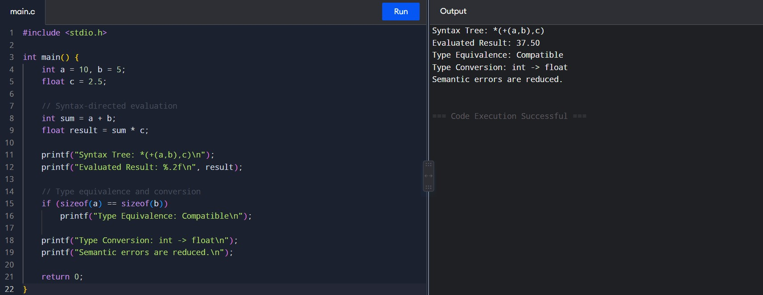

Q5. Type Checking and Type Conversion
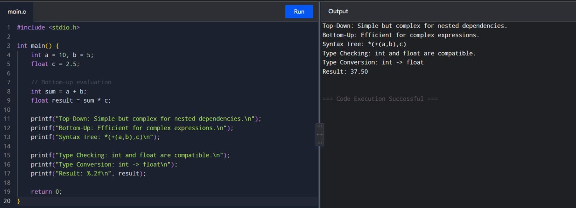
SET 4
Q1. Syntax-Directed Definition and Type Conversion
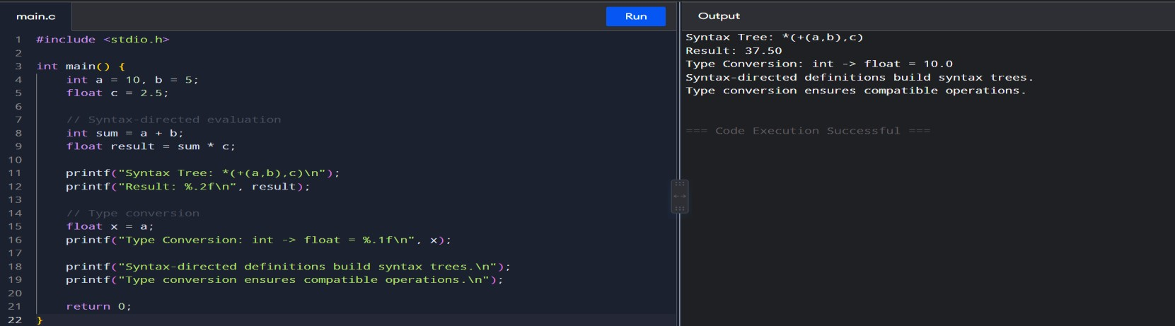

Q2. Top-Down and Bottom-Up Evaluation
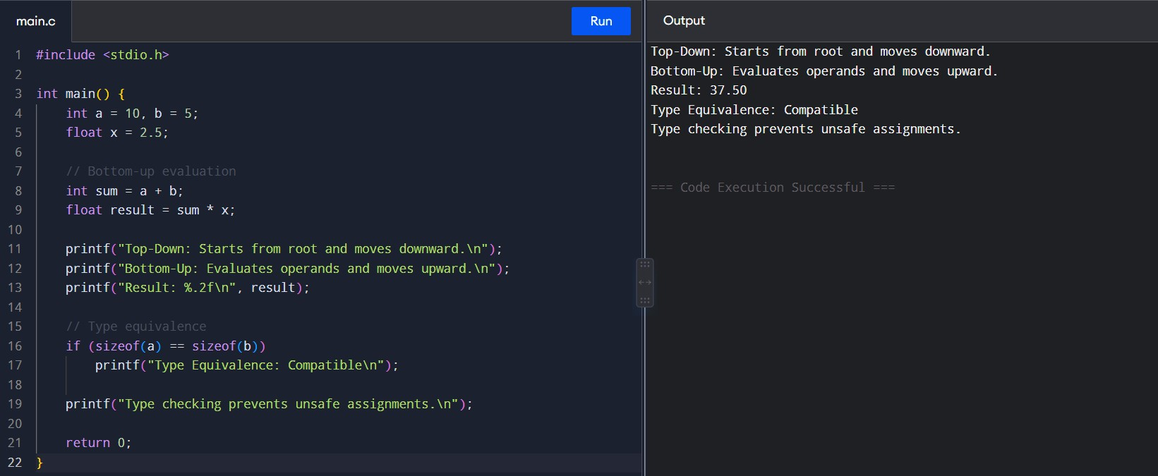

Q3. Inherited and Synthesized Attributes
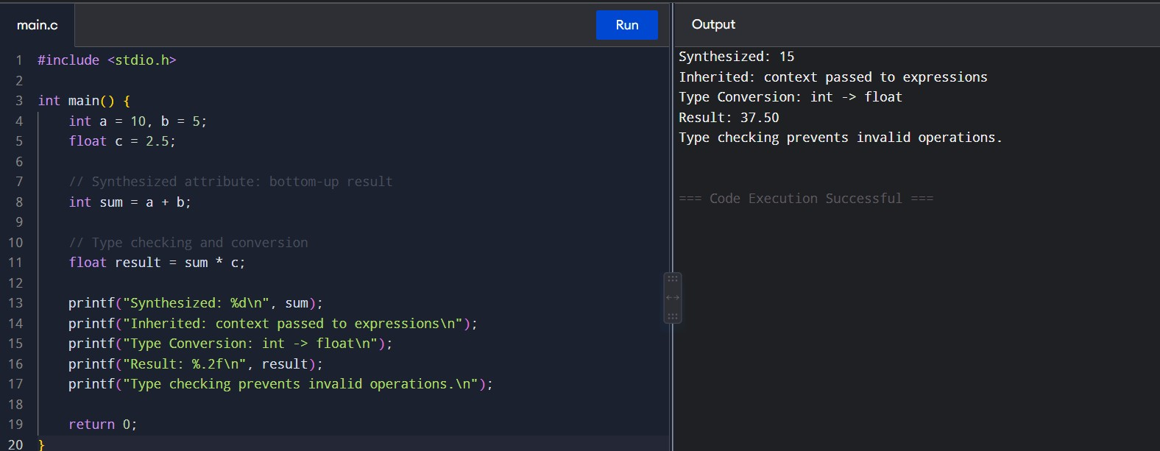

Q4. Type Equivalence and Type Conversion
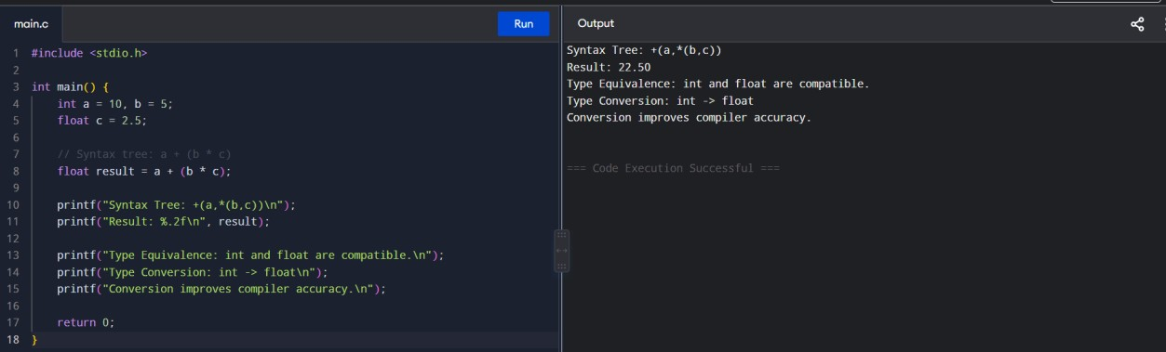

Q5. S-Attributed and L-Attributed Definitions
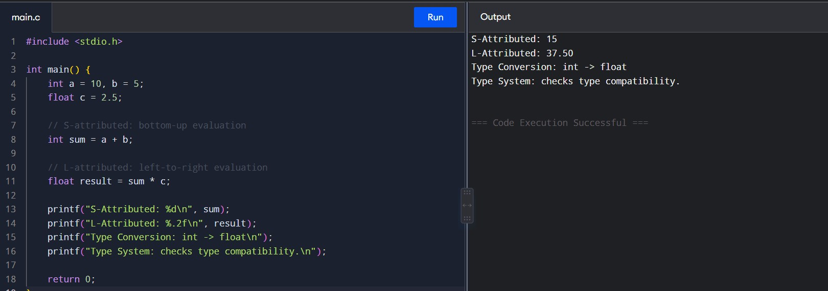

SET 5
Q1. L-Attributed Definition
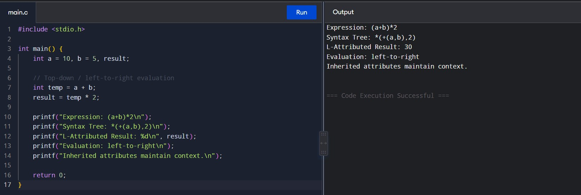
Q2. Bottom-Up Evaluation
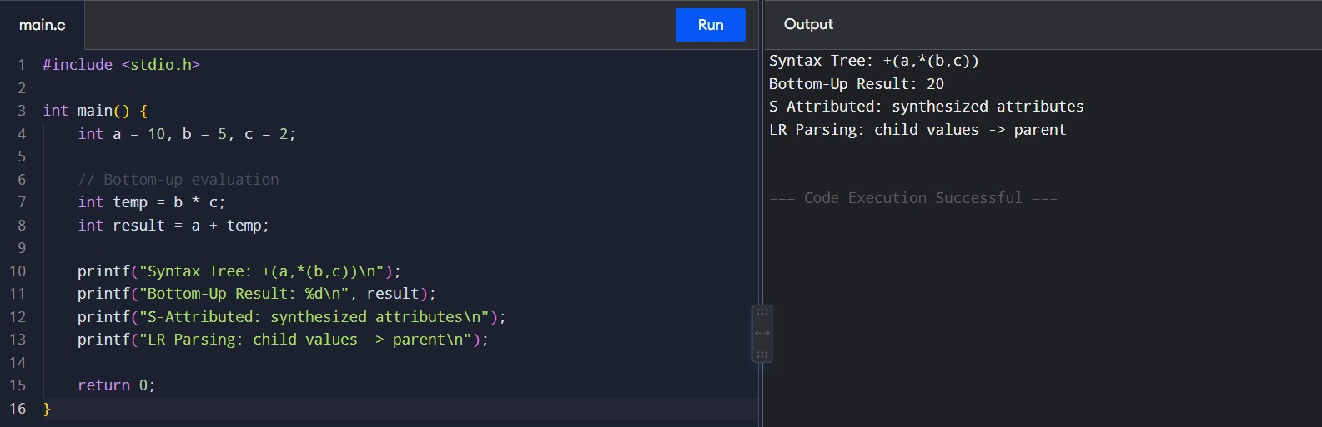
Q3. Type Equivalence
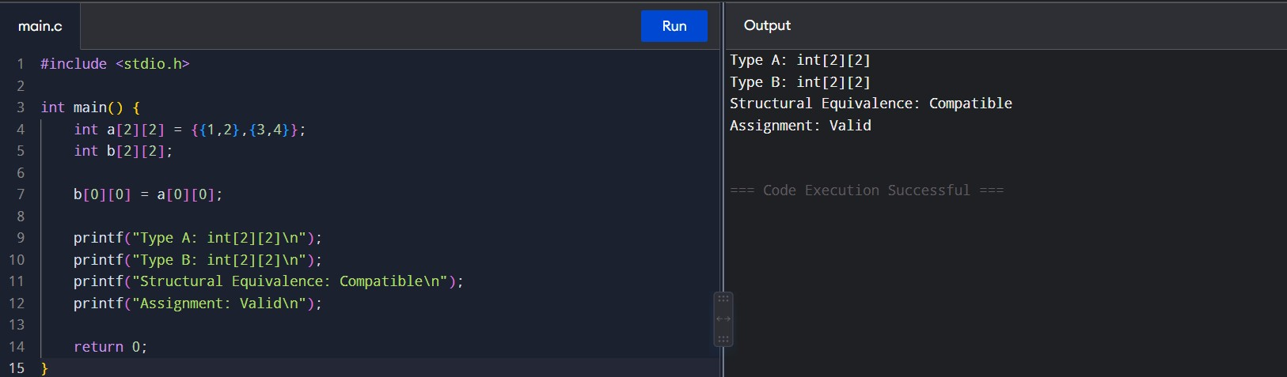

Q4. Type Checking and Type Conversion
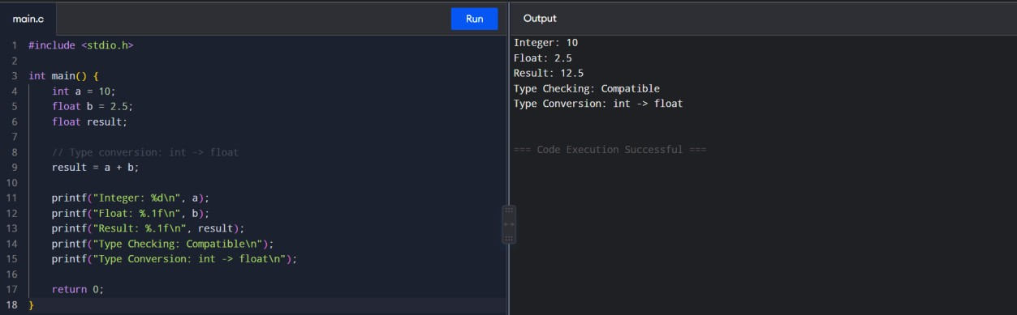

Q5. Attribute Dependency and Expression Evaluation
